**DAILY ONLINE ACTIVITIES SUMMARY**

|  |  |  |  |  |  |  |  |  |
| --- | --- | --- | --- | --- | --- | --- | --- | --- |
| **Date:** | **19-5-2020** | | | | | **Name:** | **Likhitha.M** | |
| **Sem & Sec** | **6th sem ‘A’** | | | | | **USN:** | **4al17cs046** | |
| **Online Test Summary** | | | | | | | | |
| **Subject** | | **Computer graphics and visualization** | | | | | | |
| **Max. Marks** | | **60** | | **Score** | | | **53** | |
| **Certification Course Summary** | | | | | | | | |
| **Course** | **Python for machine learning** | | | | | | | |
| **Certificate Provider** | | | **Great learning** | | **Duration** | | | **1 week** |
| **Coding Challenges** | | | | | | | | |
| **Problem Statement:** 1. We have a Letter or a word then we need add some letters to it and need to find out shortest palindrome For example we take "S": S will be the shortest palindrome string. If we take "xyz": zyxyz will be the shortest palindrome string So we need to add some characters to the given string or character and find out what will be the shortest palindrome string by using simple java program  2. Write a simple code to identify given linked list is palindrome or not by using stack. First take a Stack. Traverse through each node of the linked list and push each node value to Stack. Once the traversal & copying is done, iterate through linked list from head node again. In each iteration, pop one stack element and compare with node value in respective iteration. It is expected to match stack popped value with node value.  In case of all matches, its a palindrome. Any one element mismatch makes it not a palindrome.  3.A user will input two strings, and we find if one of the strings is a sub sequence of the other. Program prints “yes” if either the first string is a sub sequence of the second string or the second string is a sub sequence of the first string. Assume that, the length of the first string is smaller than or equal to the length of the second string.  **An expected output of the program:**  Input the first string tree Input the second string Computer science is awesome YES | | | | | | | | |
| **Status:completed** | | | | | | | | |
| **Uploaded the report in Github** | | | | | **yes** | | | |
| **If yes Repository name** | | | | | **https://github.com/likhithaMantaral/may-19** | | | |
| **Uploaded the report in slack** | | | | | **yes** | | | |

Online-test

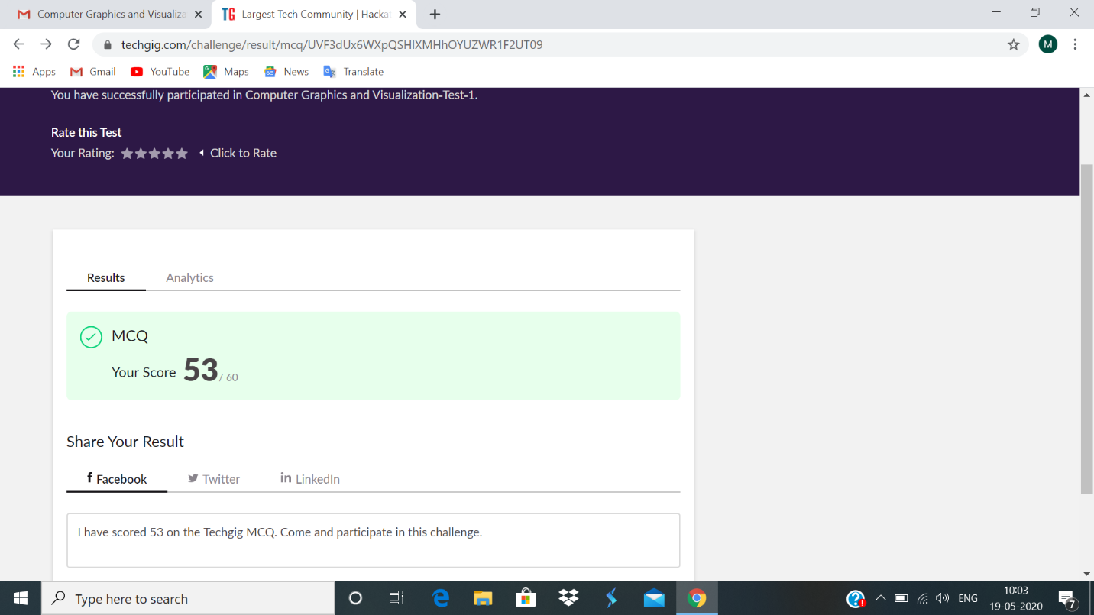

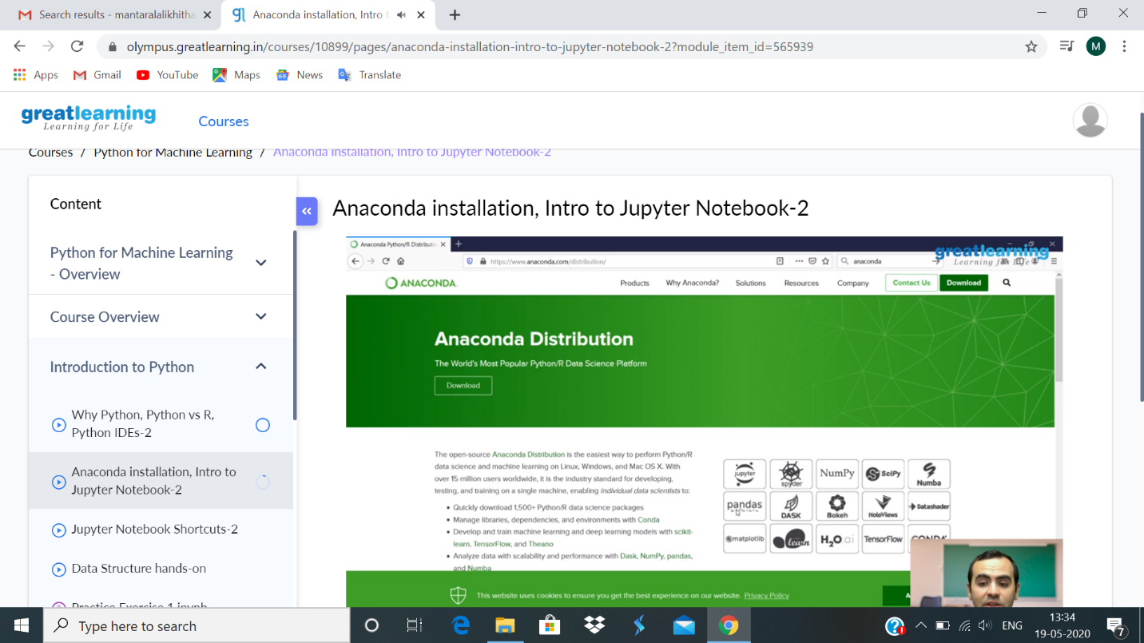

Certificate course

coding challenge